Slime acid block
Spills over the top of the block. Warps like in Slime World. Spits acid drops out. If the player touches this tile, they will be dissolved.

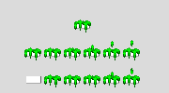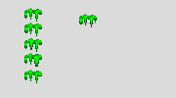

See http://lee.8bitcoder.com/bouncy/slimewarp01.gif and http://8bitcoder.com/bouncy/img/slimeanim03.gif

